


UCLPartners-Primrose Implementation Workbook



Welcome to the UCLPartners-Primrose Framework!

This workbook is designed to support you when implementing the UCLPartners-Primrose (also known as UCLP-Primrose) framework.
UCLP-Primrose has been designed to transform the care for people with Severe Mental Illness. It combines the award-winning and nationally backed UCLPartners’ ‘Proactive Care Frameworks’, that offer risk stratification and prioritisation tools to adapt workforce to patient need, with ‘Primrose-A’, the evidence-based approach to delivering intensive, tailored, integrated physical and mental health support for people with Severe Mental Illness (SMI). The original PRIMROSE intervention was proven to promote good mental health and reduce healthcare costs in a NIHR-funded national clinical trial.

This workbook will provide you with the understanding and tools you need to implement UCLP-Primrose successfully.

This workbook is supported by the information found on our ‘Information for implementation’ and ‘training resources’ webpages.

Contents
What is UCLPartners-Primrose? 4
The UCLPartners-Primrose Implementation Process 5
The UCLP-Primrose Implementation Flow Chart 5
Phase 1: Agreement and Senior Sign Off 6
Phase 2: Engagement with Key Stakeholders 7
Phase 3: Planning and Logistics 8
Phase 4: Kick-off 9
Frequently Asked Questions 10

What is UCLPartners-Primrose?

Patients with severe mental illness (SMI) die 10-20 years too early often because they do not receive the care they need. This inequality is an NHS and Integrated Care System priority.
UCLP-Primrose transforms care for people with SMI.
UCLP-Primrose helps teams to:
- Automatically identify those at highest risk of dying early and provide evidence-based care.
- Identify those who are not engaged with care and offer outreach physical and mental health support.
- Provide behaviour change interventions which improve mental health and support them with physical health and wellbeing goals.
It has 3 simple components:
- Risk stratification and search tools – to identify patients at highest risk or not engaged with care
- Materials to improve the SMI physical health check including clinical review to best treat the most important risk factors (e.g. BP and lipids)
- Materials and training for offering structured behaviour change interventions and peer support
Watch our introduction to UCLP-Primrose. Click the picture below or scan the QR code to access the video.

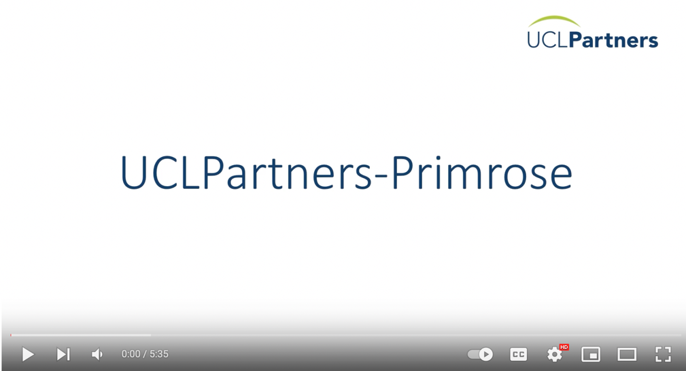

The UCLPartners-Primrose Implementation Process

Implementing UCLP-Primrose will involve many groups, including clinicians, practice managers, admin staff, allied health professionals, and more. As a team, you will go through a process to understand what you currently offer for the physical health of people with severe mental illness and how this can be incorporated into UCLP-Primrose, as well as identifying any additional resource that needs to be identified. You will then work out the adaptions necessary to ensure the framework works well for you in your local setting.

This workbook is broken down into four implementation phases to help you in this process. You can use the phase guides to structure your discussions, identify actions, as well as to provide overall shape to your implementation process. Though we have broken this down into four phases, you should feel free to spread the key objectives out over a period that suits you. We recommend regular implementation meetings at least every three weeks to build momentum and embed new ways of working. Typically the entire process of getting UCLP-Primrose up and running takes one year. The flow chart below summarises each of the phases, the possible timescales, and the key objectives to be met. The content of each meeting is detailed in the pages that follow, including supporting resources. Actions from each implementation meeting should be delegated to the appropriate person at the end of each meeting, and these should be completed before the next meeting. After stage 4 you should have UCLP-Primrose up and running in your local area, so your implementation meetings can be used for clinical reporting, tracking progress, and problem solving any issues that arise.

The UCLP-Primrose Implementation Flow Chart
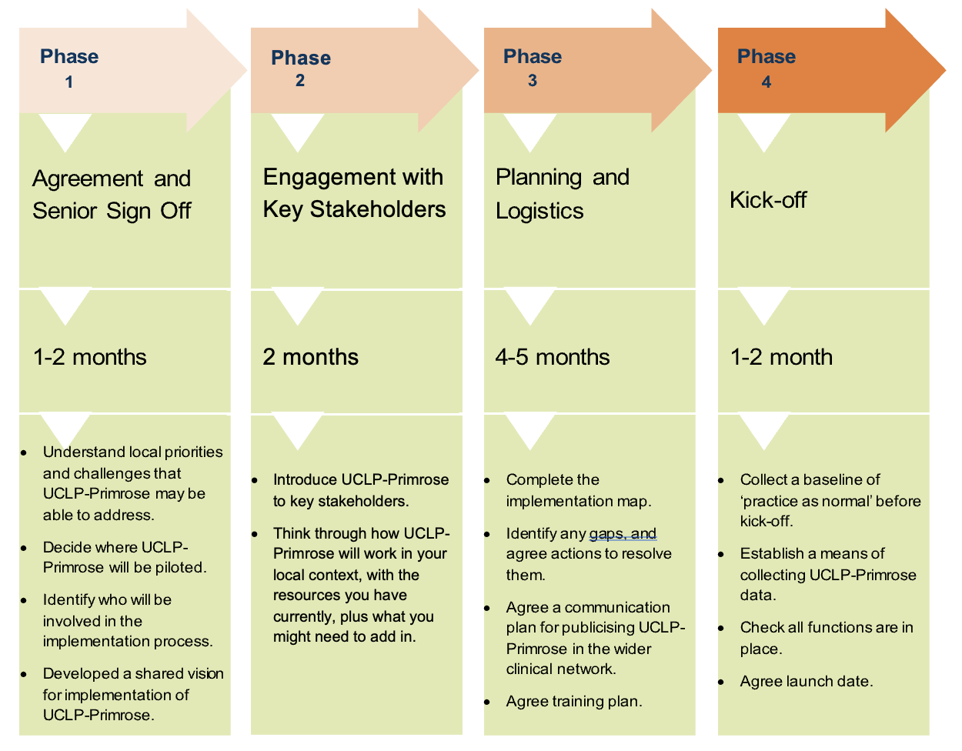

Phase 1: Agreement and Senior Sign Off
In the first phase of UCLP-Primrose you will be establishing whether this new way of working fits in with your local priorities and, if so, defining a high-level approach to the implementation process. Senior stakeholder buy-in is critical as they will determine resource allocation and pull in support.
Meeting Objectives:  - Understand local priorities and challenges that UCLP-Primrose may be able to address  - Establish senior support for UCLP-Primrose  - Decide where UCLP-Primrose will be piloted  - Identify who will be involved in the implementation process  - Develop a shared vision for implementation of UCLP-Primrose | People needed:  - Possibly an ICB lead if wide roll-out is desirable  - PCN clinical director  - Relevant Network managers  - Other key system stakeholders
Discussion Points:
- Introduction to the UCLP-Primrose framework
- Benefits of UCLP-Primrose in the context of local priorities and challenges
- Confirming the number of pilot PCNs/practices to be involved (to achieve the population health benefits and reduce health inequalities driven by cardiovascular disease, we recommend implementing UCLP-Primrose at a PCN level, with a small number of pilot PCNs to begin with), the approach to broader rollout and approach to align incentives
- Who could provide clinical leadership for UCLP-Primrose delivery
- Who could provide project management for UCLP-Primrose delivery
- Identify key local system partners required to support implementation
- Next steps (we recommend identifying key clinical and operational stakeholders and setting up a regular implementation meeting)
By the end of this meeting you should have:
Names of PCN/practices for UCLP-Primrose roll out:
Names of local project managers:
Who to invite to next implementation meeting:
Date for next implementation meeting:

Supporting Resources:
- UCLP-primrose introductory video
- UCLP-Primrose pathway map
- Information for implementing UCLPartners-Primrose resource page

Phase 2: Engagement with Key Stakeholders
Once you have senior buy-in, the next step is to get all the right people in the room. We recommend being creative about who to involve, for example, it can be fruitful to involve third sector colleagues. When you have good clinical and operational representation, you can then agree how to tailor the UCLP-Primrose framework to your local context. Key to success is having both a senior clinical lead, for example a GP mental health lead for the borough or network to drive forwards the new way of working, and on the ground project managers who know your local context well enough and have the capacity to support the implementation process.

Meeting Objectives:  - Introduce UCLP-Primrose to key stakeholders  - Think through how UCLP-Primrose will work in your local context, with the resources you have currently, plus what you might need to add in. | People needed:  - Clinical lead for the project (e.g. GP mental health lead)  - Project manager(s)  - Representation from key clinical stakeholders who may be involved with delivering the framework (pharmacists, social prescribers, GPs, nurses, mental health professionals, HCAs, peer coaches)  - Operational leads  - Network managers
Discussion Points:
- Introduction to UCLP-Primrose model
- Benefits of UCLP-Primrose in the context of local priorities and challenges
- Identify what’s already available for people with SMI, and discuss whether this could be part of the UCLP-Primrose model (e.g. if HCAs are already providing the annual health check)
- Identify gaps where extra provision will be necessary (e.g. providing the ‘intensive behaviour change’ part of the pathway)
- Allocate admin support
By the end of this meeting you should have:
Names of people already involved in delivering care for people with SMI:

Identified gaps in current resources and actions to resolve this:

Supporting Resources:
- UCLP-primrose introductory video
- UCLP-Primrose pathway map

Phase 3: Planning and Logistics
During this phase you will start to think through the logistics in more detail. If you haven’t already done so, this part of the process will help to identify who will provide each part of the pathway, plus the finer mechanisms involved at each point of delivery. You will also need to put together a training plan, so that everyone involved in the framework has the necessary skills to deliver holistic, positive care.

Meeting Objectives:  - Complete the implementation map  - Identify any gaps, and agree actions to resolve them  - Agree a communication plan for publicising UCLP-Primrose in the wider clinical network  - Agree training plan | People needed:  - Implementation group (including key clinical stakeholders, project managers, operational leads).
Discussion Points:
- Go through the Implementation Map to agree the logistics of UCLP-Primrose. Where are the gaps? How can you fill them? You will need to fill out one implementation map per practice involved.
- Are you involving VCS organisations? Do you need data sharing agreements?
- Discuss a communication plan for sustained publicising of UCLP-Primrose in the wider clinical network. You can use our UCLP-Primrose introductory videos or implementation video to support with this. We recommend publicising in the GP bulletin/webpage/forum, practice manager’s forum, attending practice meetings, using social media e.g. any practice Whatsapp groups or intranet pages, newsletters etc., identifying a UCLP-Primrose ‘champion’ in each practice, putting up posters in surgeries).
- Discuss a training plan. Anyone delivering the ‘intensive behaviour change’ part of the pathway must complete our e-learning modules and then attend in-person training. Your training plan should include: sending out all the training resources to all involved in UCLP-Primrose, request support from a local training provider (e.g. your core team psychologist), request training support from a person with lived experience (e.g. from your Recovery College), introduce the lesson plan to both trainers and set dates for the training. It is beneficial for others involved in UCLP-Primrose to also attend the training.
Trainers | Setting | Timings | Rationale for training
1 x Health Psychologist/Behaviour Change Specialist (who has received training and is experienced in the use of communication skills and behaviour change strategies outlined in UCLP-Primrose)  1 x Lay Tutor (who can share lived experience of severe mental illness and making improvements to their physical health) | In person or online delivery | 1 hour trainer prep  15 mins pre-brief on the day  3.5 hour delivery time | For learners to build their skills and confidence in using communication skills and behaviour change strategies to engage and support patients to make changes that improve their cardiovascular health

By the end of this meeting you should have:
Names of people to contact about their involvement or role in UCLP-Primrose delivery:
Name of person leading on communication plan:
Name of person leading on organising training:
Name of person who will run the search and stratification tool in each practice:
Supporting Resources:
- UCLP-primrose implementation map
- UCLP-Primrose training resources
- How do I set up UCLP-Primrose resource page
- UCLP Proactive Care Frameworks, module 2, ‘Risk Stratification’

Phase 4: Kick-off
This is the final stage of the initiation process. During this stage you will check that all your functions are in place, plus understand your baseline before kick-off, so that you can track changes as they occur. It’s important to understand: what are you hoping to achieve by implementing UCLP-Primrose, and how will you know if you’ve achieved this? By this point, everyone involved in the framework should have a good understanding of what their role is, where all the supporting resources are located, how to refer patients between each part of the pathway, and who they can go to if they have any problems or concerns.

Meeting Objectives:  - Collect a baseline of ‘practice as normal’ before kick-off  - Establish a means of collecting UCLP-Primrose data  - Check all functions are in place  - Agree launch date | People needed:  - Implementation group (including key clinical stakeholders, project managers, operational leads).
Discussion Points:
- Search and stratification tool: has the tool been uploaded into Emis/SystmOne in all practices? Has someone run the searches? What are the baseline numbers in each priority group?
- Discuss use of the UCLP-Primrose template – is this useful for you? If so, who can upload it, and who will inform all involved about it?
- Training: have all relevant staff completed the e-learning and attended the in-person training?
- Check all functions in place (search tool, invites, physical health check, clinical review, intensive support, outreach, mental health review, peer support, wider social support)
- Agree approach for sharing learning (community of practice) and use of quality improvement approaches
- Define data and evaluation approach including key metrics required
- Ensure mechanisms for risk management and escalation in place
- Launch date
By the end of this meeting you should have:
Baseline numbers in each priority group, per practice:
Name of person to upload UCLP-Primrose template:
Name of person to establish and publicise UCLP-Primrose community of practice:
Risk management process:
Agreed outcome/process measures:
Launch date:

Supporting Resources:
- How do I set up UCLP-Primrose resource page
- Community of practice approach
- UCLP Proactive Care Frameworks, module 4, ‘Taking a QI Approach’

Frequently Asked Questions

- We already have a process for performing the physical health check for people with SMI, why should we do this too?
The physical health check is a great first step for improving the health of people with SMI, but should represent the floor and not the ceiling of our ambition. In our experience, many patients complain about not receiving their test results and minimal follow-up to address abnormal results from the health check. UCLP-Primrose helps combat this by formalising a comprehensive care pathway. It also makes sure that any patients who do not respond to their invite for the health check (usually 30-40% of patients) are not overlooked, either by tailoring support to them or by going to them at home. The result is more consistent, equitable, holistic care.

- If we involve third sector colleagues, or secondary care teams, how do we share data?
Unfortunately, most organisations are using different electronic patient records systems. This makes it difficult to share appropriate patient data safely, accurately, and easily, even when it benefits the patient. One way to overcome this is to develop a data sharing agreement. Please see the published case study from Equally Well in Sheffield, which includes a data sharing agreement, for guidance.

- Who should receive the UCLP-Primrose training?
We recommend that everyone involved in UCLP-Primrose delivery looks at the training materials. As a minimum everyone should look at the manual that describes their part of the pathway (e.g. the mental health specialist performing the desktop review for those who don’t respond to the invite to their health check should minimally look at the Mental Health Review document). The exception to this is the training for the Intensive Behaviour Change part of the pathway. Whoever is delivering this part needs to complete the entire training package (manual, video playlist, e-learning and in-person training).

- How long will the training take? Do I need to watch all the training videos?
The training (including reading all the resources, looking at the videos, completing the e-learning, and attending the in-person session) should take approximately one day if taken back-to-back. However, you should feel free to look at the resources that are most relevant to your role and your knowledge level. For example, the UCLP-Primrose video playlist includes information about severe mental illness, so you would not need to look at those particular videos if you are already a mental health specialist.

- Why should we have a person with lived experience supporting with the delivery of the training?
It’s important to represent the experience of the person receiving the intervention as part of the training. People with lived experience, or Experts by Experience, bring exceptional insight and guidance, and help break down any assumptions or concerns clinicians might have. They also help bring the material to life by providing first-person accounts.

- Who do I ask for help? How do I escalate any risks?
In the context of clinical practice, it is best practice to identify a person within your system who can champion UCLP-Primrose, answer any questions, and be a point of contact for any problems. This should be someone like a psychologist or doctor. If you need to escalate a risk then you should contact your lead clinician e.g. the GP lead for your practice. Please confirm these contacts and the risk management process before you begin delivering UCLP-Primrose.

- Who do we go for when we need help or if something goes wrong?
For implementation support you can speak to your implementation lead or local project manager.

- Where will the search stratification tool appear on S1/EMIS?
Please see our webpage and section ‘Step Two: Using the Search Tool’ for help with the stratification tool.

Once you have downloaded the tool (into EMIS for example) it will look like this:

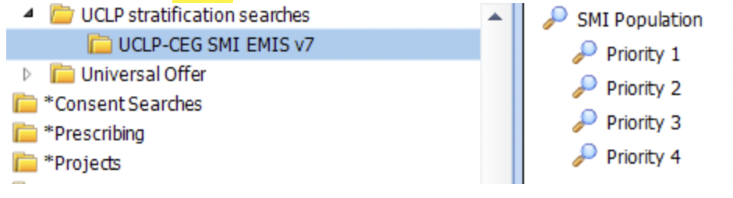

- How do we refer within the pathway?
You will need to agree when and how to refer patients within the pathway. The best way to do this is to use our implementation map and discuss each point. It’s also useful for the person(s) delivering the intensive support part of the pathway to set up a separate email so that they can be contacted directly.

- Which parts of the pathway or appointments is it ok to do virtually or over the phone?
Some patients will need more flexibility around their appointments. We recommend that as a minimum the first and last appointment should be in-person. However, this will not always be possible so please work with the patient to decide the best course of action with them.

- Who should have a clinical review?
All patients should have a clinical review. Even if a person does not have any abnormal results from their health check, a clinician will need to review their medications (psychiatric and physical), and have a general discussion about their health e.g. to promote cancer screening, smoking cessation services etc. This may be the only health appointment the person has all year so it’s important to listen and work proactively.

- Who gets the intensive support for behaviour change?
It is up to the patient and clinician to decide together whether intensive support would be useful. If you have enough resource, then feel free to offer it widely. However, if your resource is more limited then those with the greatest risk factors should receive the intervention. Not everyone will need or want intensive support, and many people will benefit from brief support and guidance during the health check or clinical review.

- What do we do if a patient repeatedly doesn’t attend the intensive behaviour changes sessions?
Please be as flexible as possible with patients, there may be several reasons they are not arriving for their appointment. If this keeps happening and you’re not sure why, we recommend that you speak to the mental health specialist involved in the pathway to get guidance and come up with an action plan to help support the patient.

- What do we do if there are people who would benefit from UCLP-Primrose but do not fit the criteria, e.g., have a diagnosis but it is not classed as a 'severe mental illness'?
The GP SMI register is quite a restricted group, so there will be people who are not on the register who would benefit from more support. If you feel the person would benefit from the intervention, feel free to offer it to them.

- How should we get feedback from the patients?
We recommend using DIALOG+ to collect feedback from patients.

- Can I use what I have learned in UCLP-Primrose in other consultations and patient interactions?
Absolutely!

